4.1 Software and Hardware Architecture
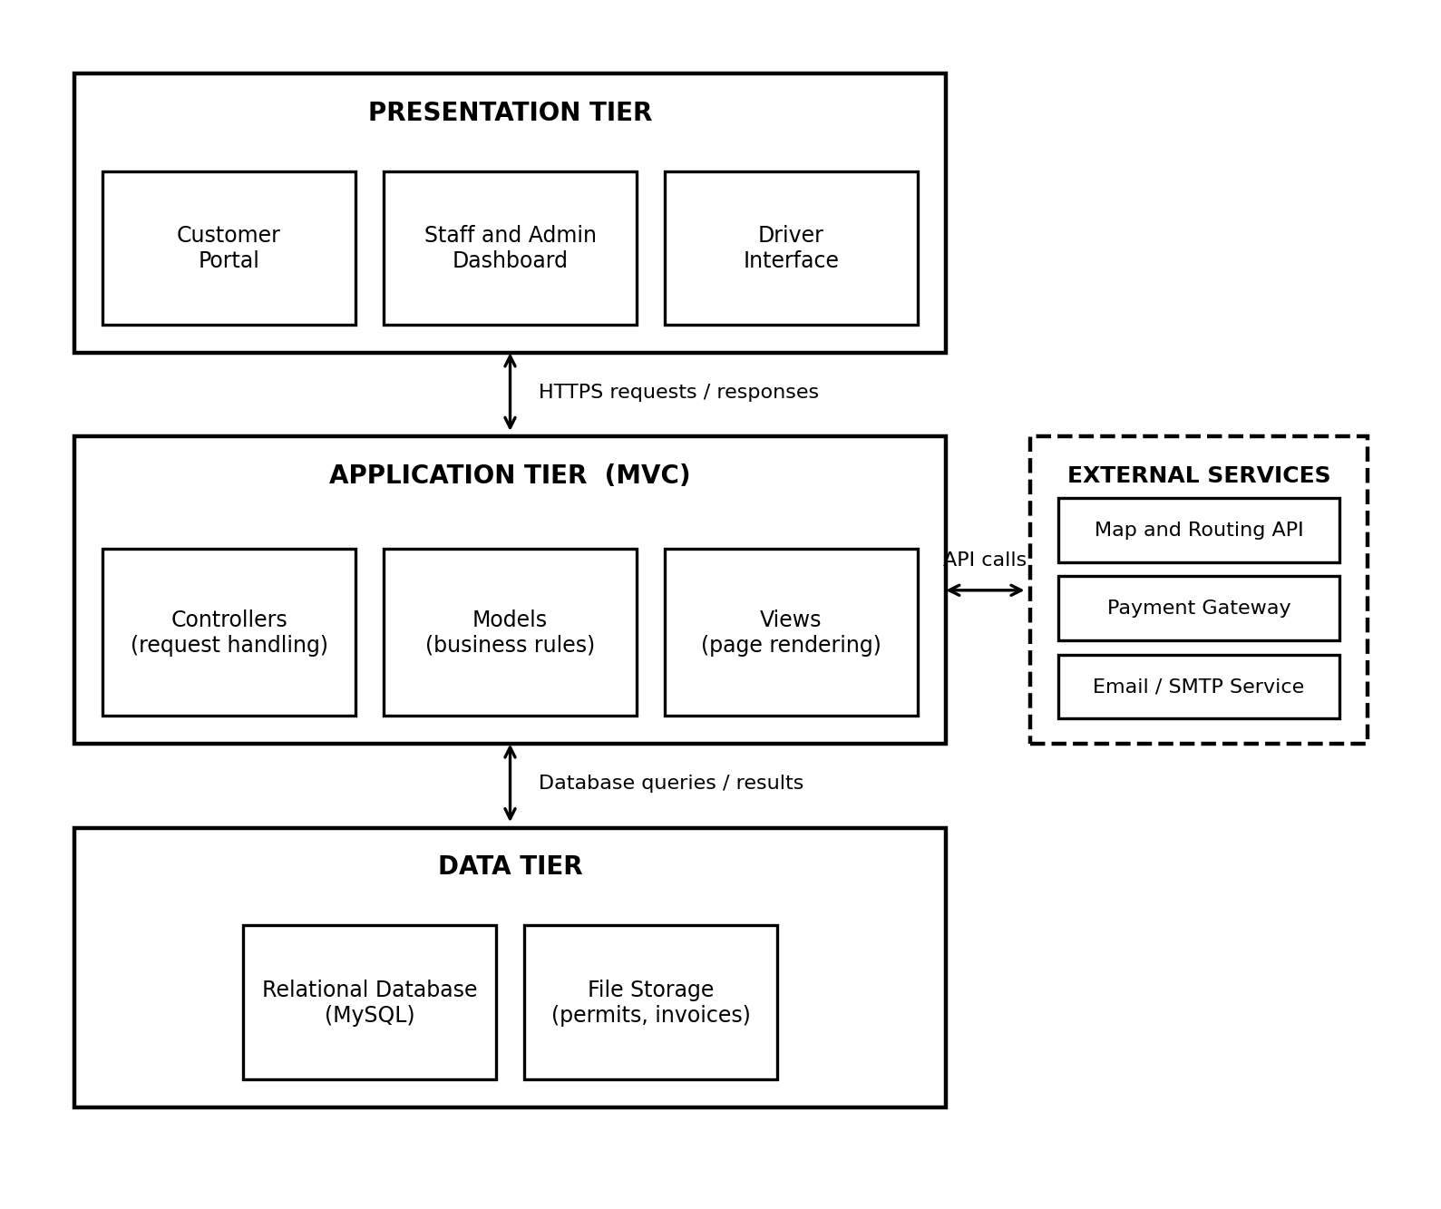
Figure 4.1: Software architecture of the CWCS
The system consists of three layers, each with a single task. Who the user is determines what they will see – customers will see booking screens, staff will see approval and reporting screens and drivers will see a simple screen with their run for the day. The Application layer is the part of the system that thinks about it and is built as Model, View and Controller as per the requirement of NFR11. All of the rules are laid out here and they are: blocking the harmful waste out of a regular bin, determining an approximation of the cost before the customer confirms, and not allowing a truck to be booked more than once in a slot. The data layer only accesses and returns data, and the data in the database is stored as files so that backups remain quick and the uploaded permits can be stored as files to ensure quick backups. Three positions that we outsourced, but did not create: maps, card payments, email. If the rules get changed later by BINCOL, we can change the rules in one location – that is the rules layer – instead of having to go through each screen for the changed rules.

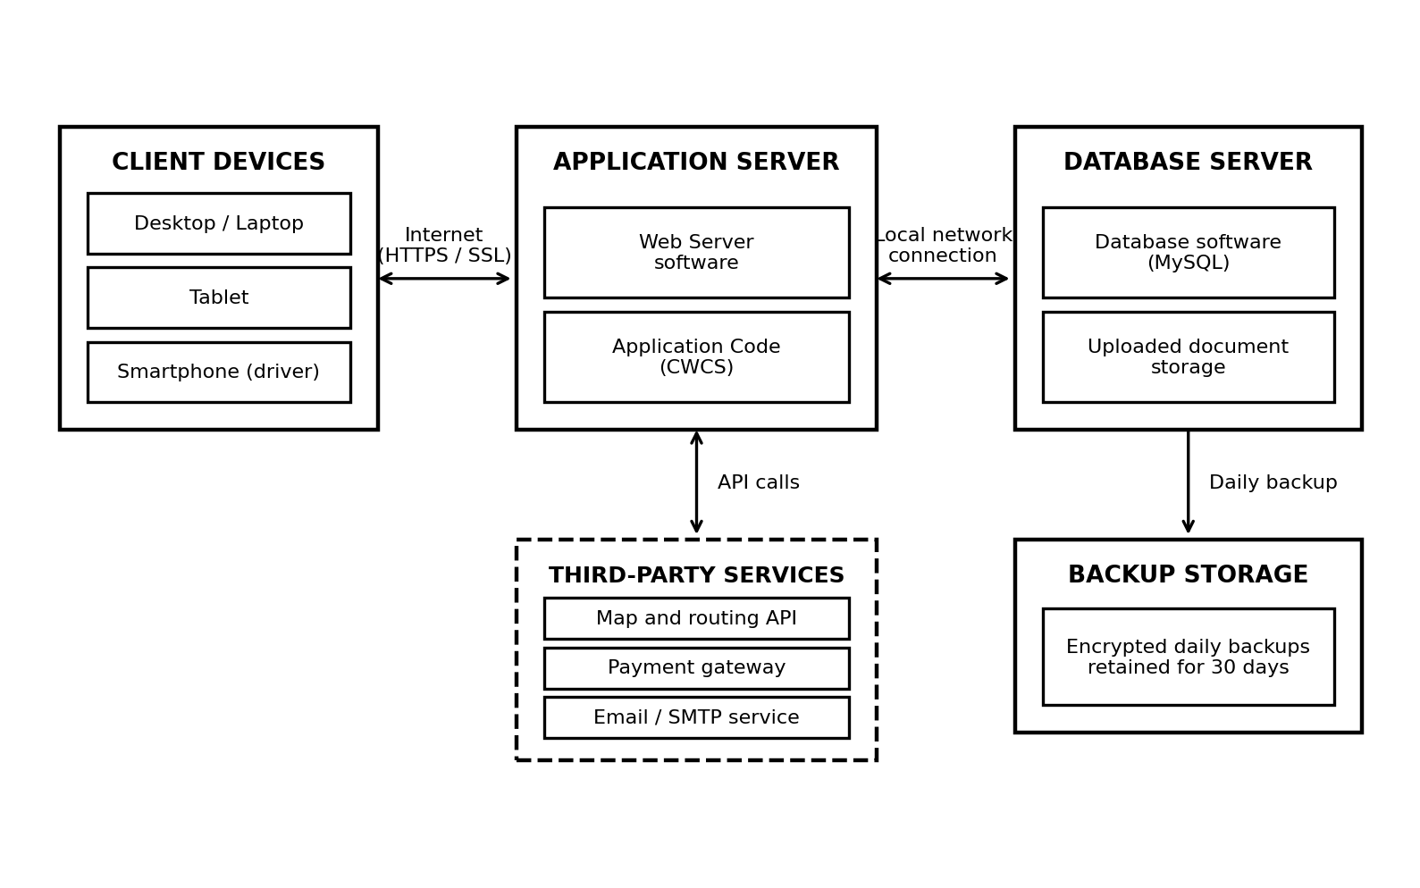
Figure 4.2: Hardware architecture of the CWCS
The hardware side, of course, is that users don't require anything to be installed on their device; all they need is an up-to-date browser, which is why the user can work on a laptop while the driver uses a phone within the truck. The Application Server hosts the web server software and our code, all requests go through the Application Server. I'm not, on purpose, putting the database on a second machine because if I did, it's going to be slow to load a page for a customer who is in the middle of trying to book a pickup for their car, and we're only allotted 3 seconds to load a page on NFR1. Backups are stored on separate storage, as the same disk as the database will be lost with the database itself, and NFR14 requires recovery within 30 minutes. We recommend a 4 core, 8 GB application server and a 2 core, 8 GB database server hosted in an Australian region, to store customers' data in Australia within the live system, to meet NFR15. The team will be working on the local area during the development process using XAMPP or Laragon.

